**Exploration and Visualisation of Dataset**

**ANIRUDH K N**

**310619104007**

**Team ID PNT2022TMID09237**

**Administration by Profit**

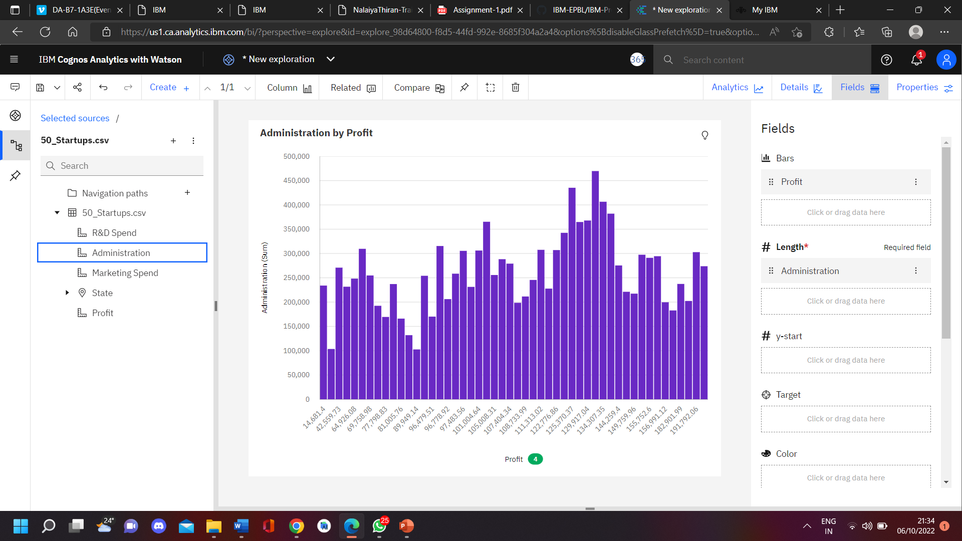

**Profit and State by Marketing Spend and Administration**

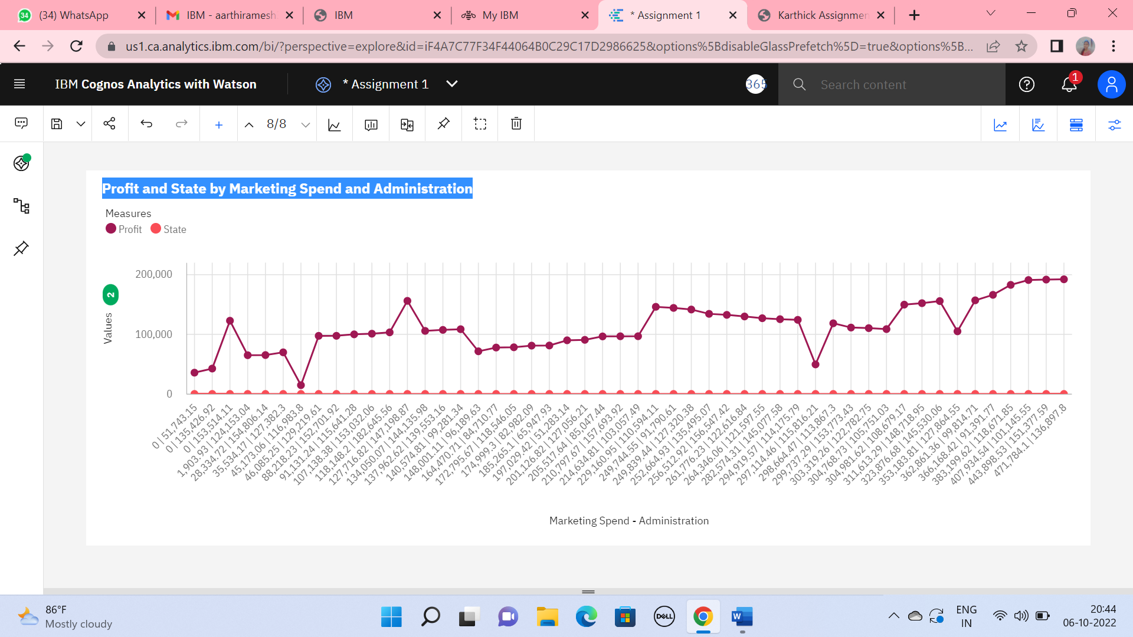

**R&D Spend by Marketing Spend**

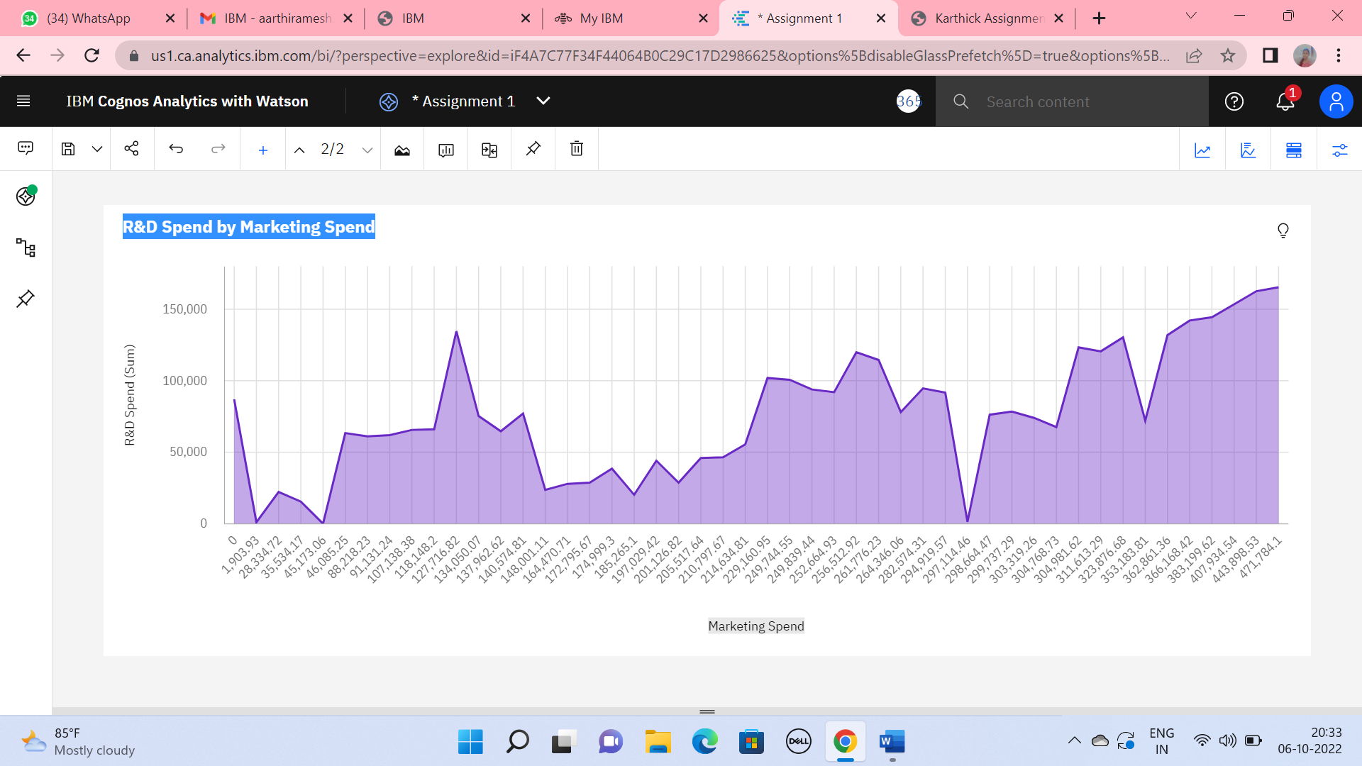

**Marketing Spend by Administration**

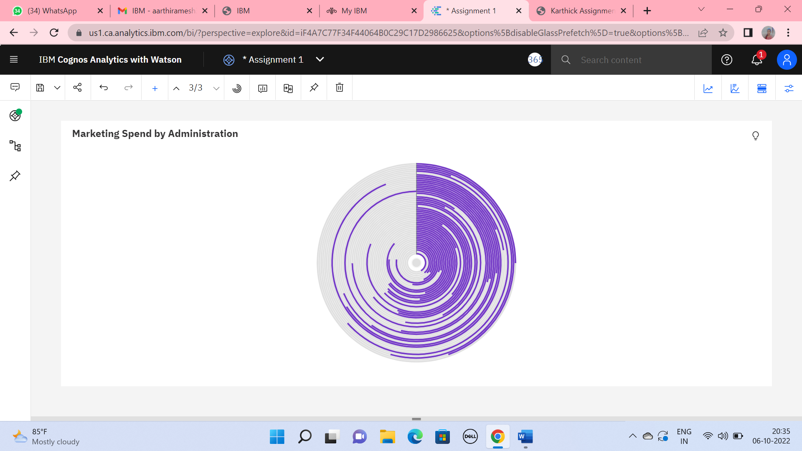

**Administration by R&D Spend**

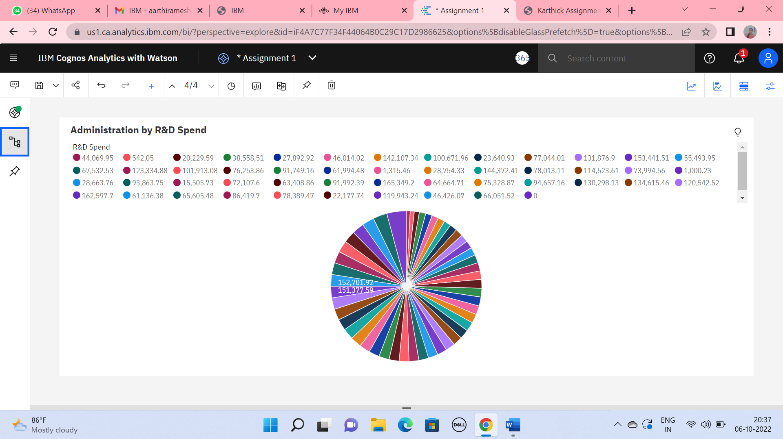

**Administration by Profit and State**

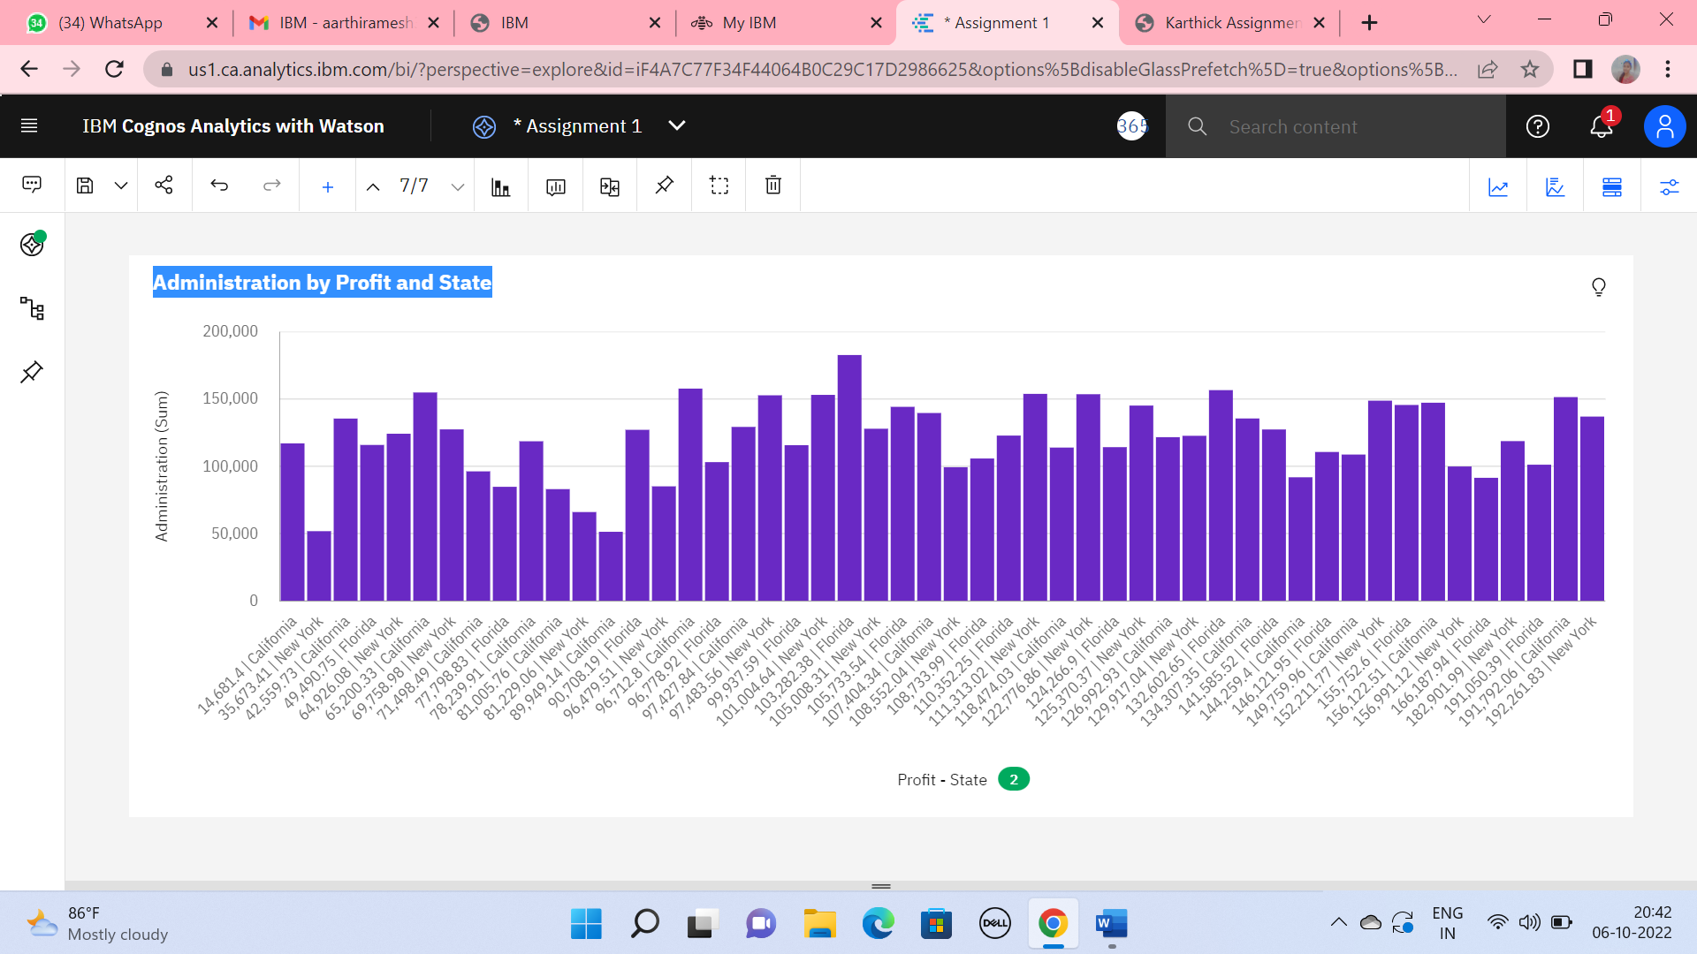

**Administration, R&D Spend, Profit, State**

